PRODUCT OWNER DOCUMENTATION
Automated Cryptocurrency Price Monitoring and Email Notification System
Figure 1. Use-Case Diagram
The Administrator manages coins, configured price ranges, and email recipients. GitHub Actions starts scheduled monitoring. The system retrieves prices from CoinLore, compares them with configured ranges, and uses Gmail SMTP to send notifications when the condition is met.
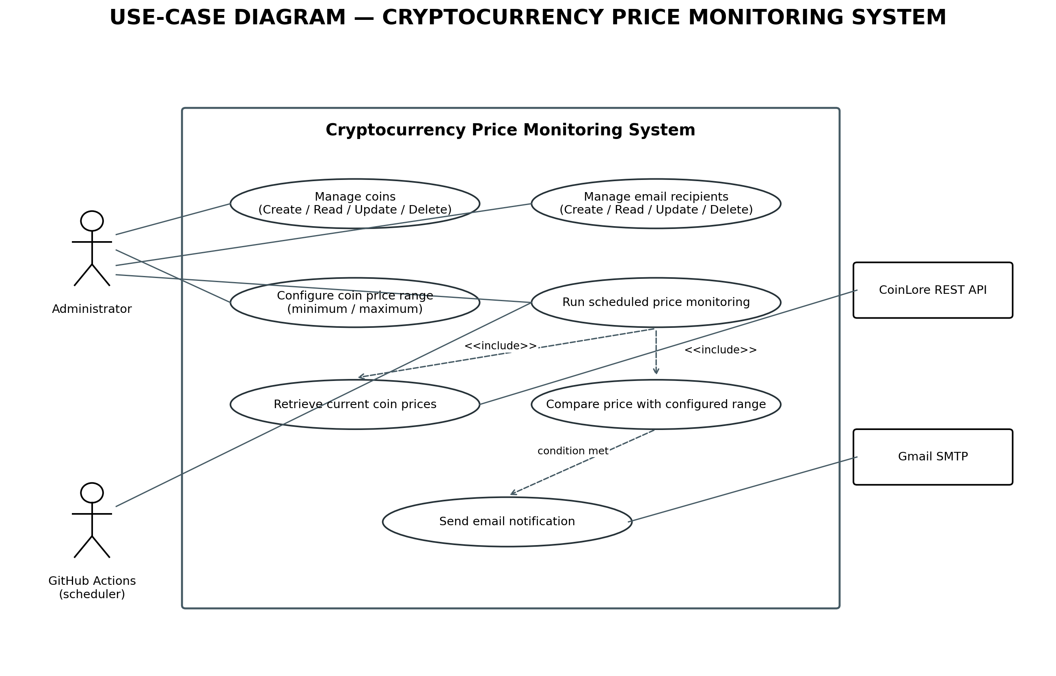
Verification note: confirm the exact workflow schedule, price-range comparison rule, and notification behavior against the current README.md and source code.
Figure 2. Sequence Diagram — Add Coin
The administrator submits coin information. registerCoin.js sends the input through Zod validation, then calls coinService.js to persist the coin using the Coin model and PostgreSQL database. Validation and database failures must not be reported as successful saves.
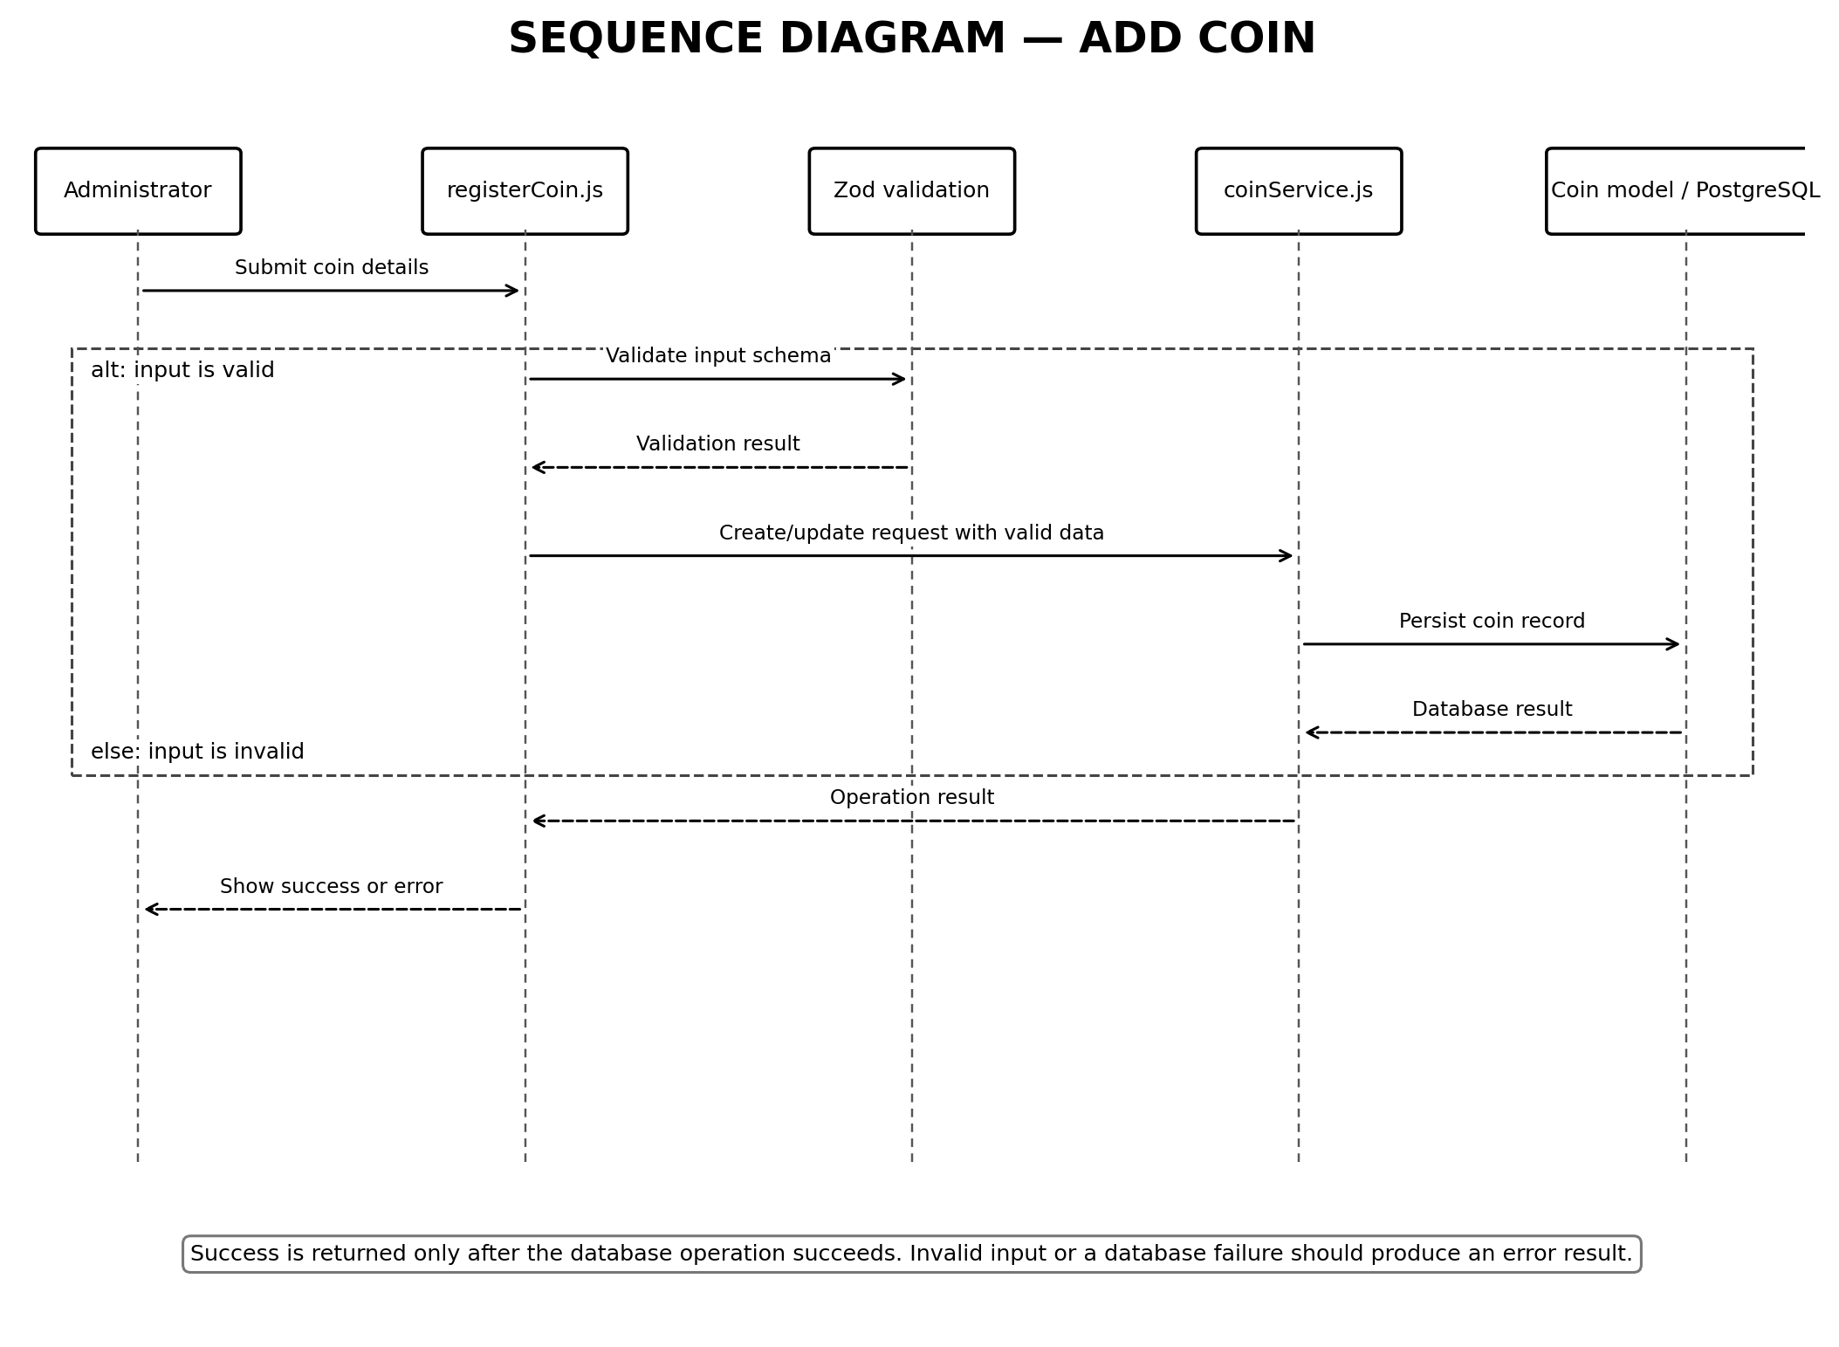

Figure 3. Sequence Diagram — Add Email Recipient
The administrator submits recipient information. registerEmail.js validates the input with Zod and calls emailService.js to save the recipient through the Email model and PostgreSQL database.
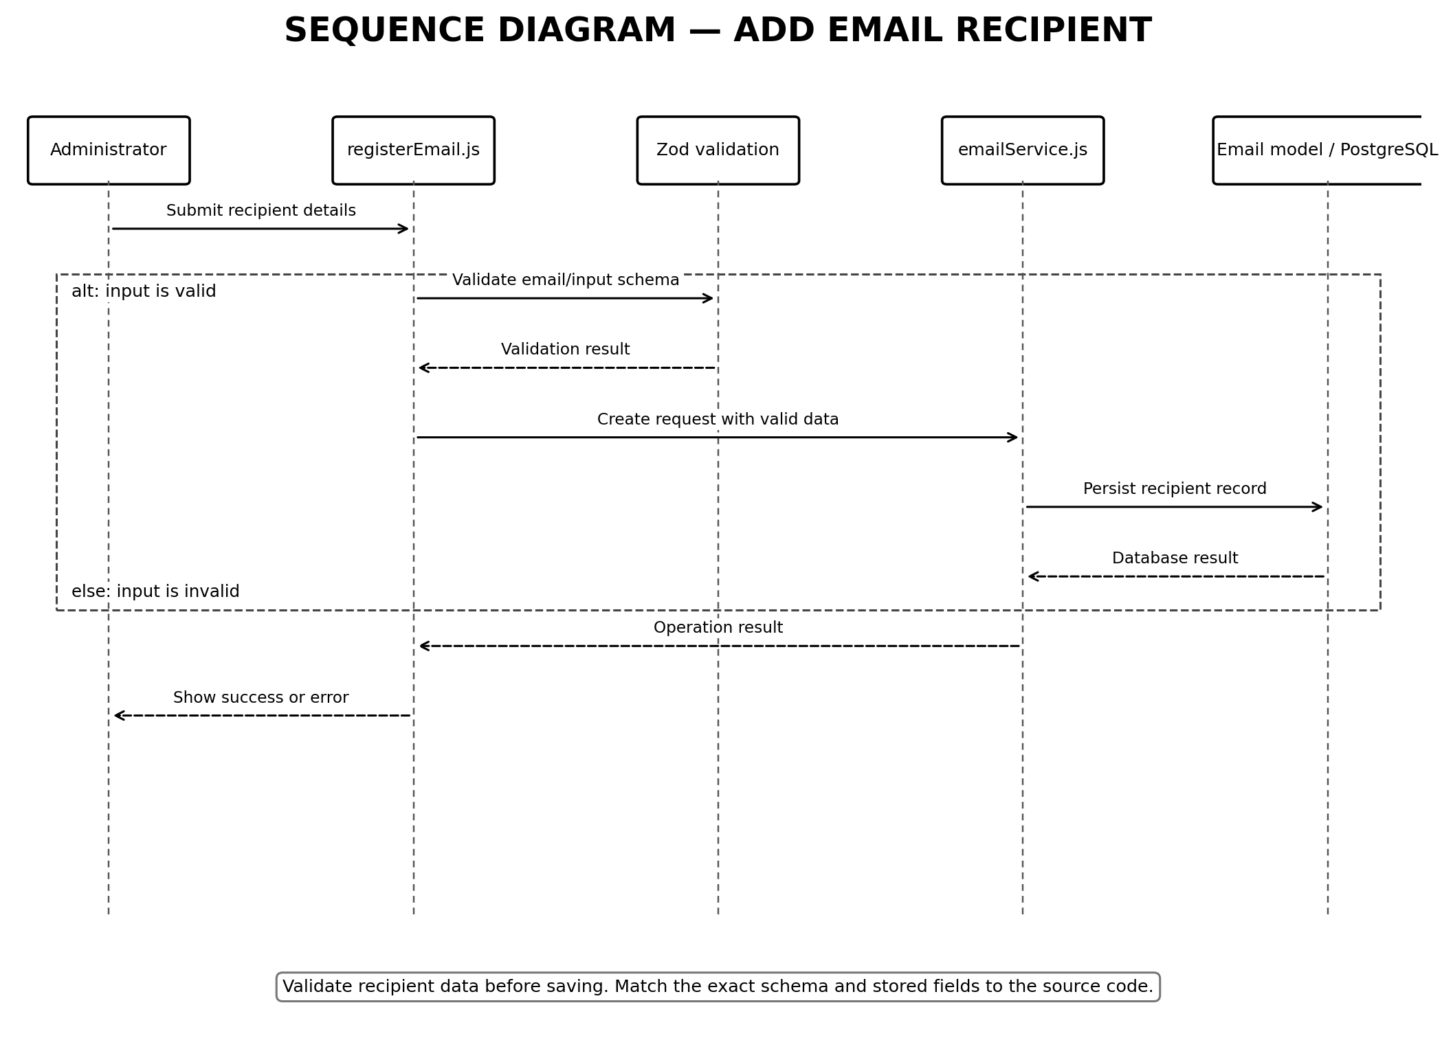

Figure 4. Sequence Diagram — Monitor Cryptocurrency Price
GitHub Actions triggers worker.js. The worker loads configured coins and ranges, requests price data through coinLoreService.js, compares the price with the configured condition, and requests notification only when that condition is met.
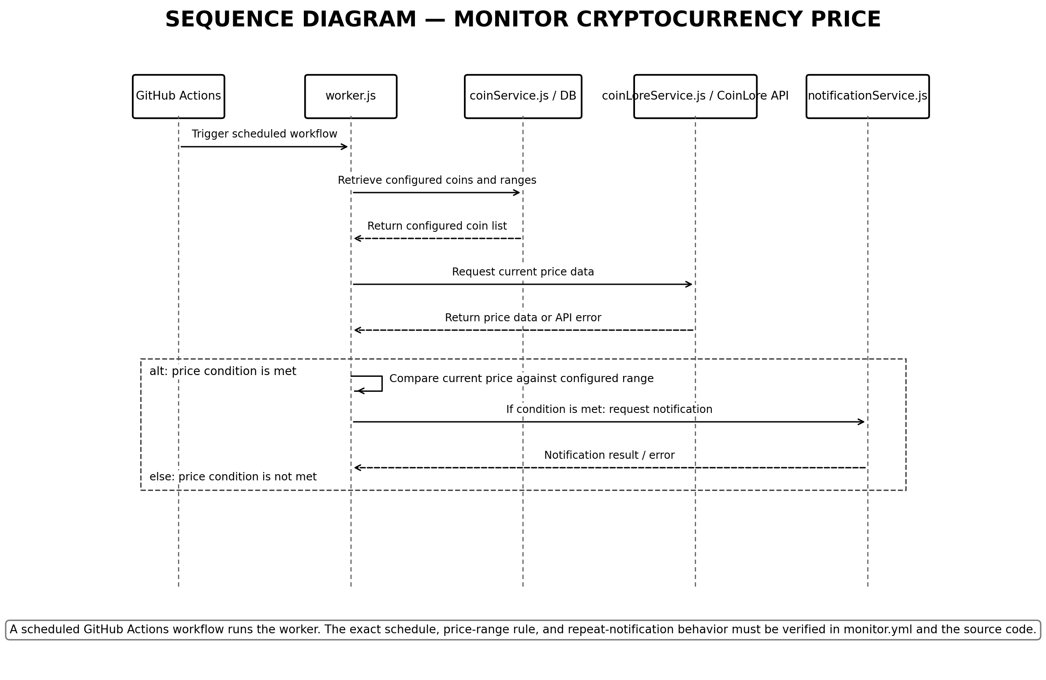
Verification note: confirm the exact workflow schedule, price-range comparison rule, and notification behavior against the current README.md and source code.

Figure 5. Sequence Diagram — Send Email Notification
After a price condition is met, worker.js calls notificationService.js. The notification service retrieves configured recipients through emailService.js and sends the message through Gmail SMTP.
